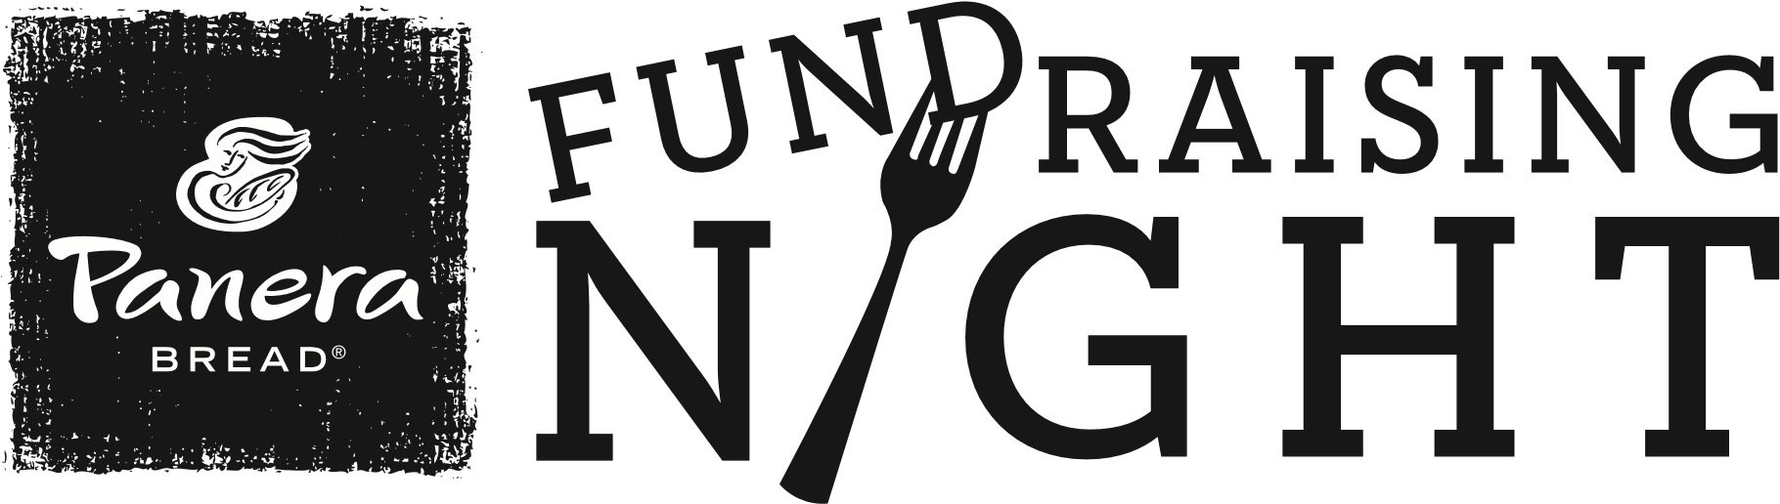
Help support
Fort Bend Museum Association Docents
Tuesday January 12, 2015
4:00 – 8:00 pm
at the Panera Bread bakery-cafe at
24401 Southwest Freeway, Rosenberg, Tx 77471
Bring this flyer when you dine with us on January 12th, and we’ll donate a portion of the proceeds from your purchase to Fort Bend Museum Association Docents. It’s a handcrafted, delicious meal, all for a great cause!
Learn more about Fundraising Nights at Panera Bread at:
www.PaneraBread.com/fundraiser

